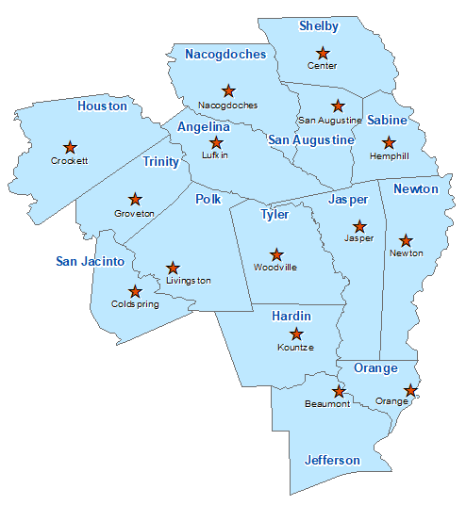Shelby County Summary 2021

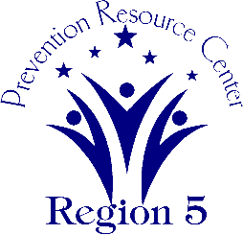The Prevention Resource Center (PRC) provides data for all 15 counties in Region 5. This is a summary of a portion of the data reported in the 2021 Regional Needs Assessment for Shelby County. The RNA focuses on underage drinking and tobacco use and on the abuse of prescription medication as well as other illicit drugs.

Population Race/Ethnicity

25,537 White Hispanic Black Asian Other

15,466 5,119 4,447 99 406

(60.6%) (20.0%) (17.4%) (0.4%) (1.6%)

Population Growth Language

0.4% English – 81.8% Other Than English – 18.2%

Median Household Income Unemployment Rate

$42,522 6.8

Crime Rate Single-Parent Households

12.8 per 1K 1,034 (11.1%)

Life Expectancy Suicide Rate

74.9 years 14.0 per 100K

OSAR Screenings Youth Served by Prevention

40.3 per 10K 18,158