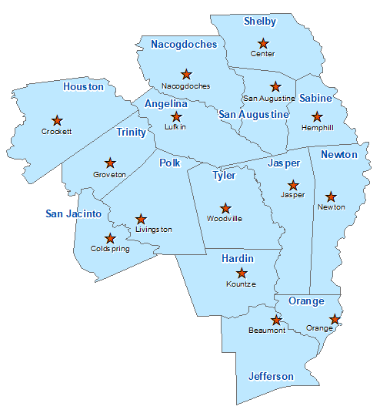San Jacinto County Summary 2021

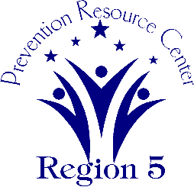The Prevention Resource Center (PRC) provides data for all 15 counties in Region 5. This is a summary of a portion of the data reported in the 2021 Regional Needs Assessment for San Jacinto County. The RNA focuses on underage drinking and tobacco use and on the abuse of prescription medication as well as other illicit drugs.

Population Race/Ethnicity

29,085 White Hispanic Black Asian Other

20,759 4,670 2,842 143 671

(71.4%) (16.1%) (9.8%) (0.5%) (2.3%)

Population Growth Language

10.2% English – 87.2% Other Than English – 12.8%

Median Household Income Unemployment Rate

$41,614 8.1

Crime Rate Single-Parent Households

26.0 per 1K 362 (3.6%)

Life Expectancy Suicide Rate

77.2 years 16.9 per 100K

OSAR Screenings Youth Served by Prevention

18.9 per 10K 7,137