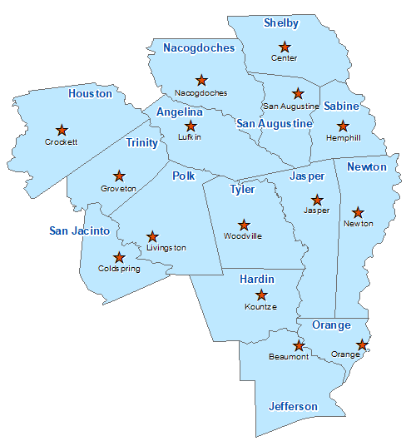San Augustine County Summary 2021

The Prevention Resource Center (PRC) provides data for all 15 counties in Region 5. This is a summary of a portion of the data reported in the 2021 Regional Needs Assessment for San Augustine County. The RNA focuses on underage drinking and tobacco use and on the abuse of prescription medication as well as other illicit drugs.

Population Race/Ethnicity

8,365 White Hispanic Black Asian Other

5,483 738 1,970 29 145

(65.5%) (8.8%) (23.6%) (0.3%) (1.7%)

Population Growth Language

-5.6% English – 95.4% Other Than English – 4.6%

Median Household Income Unemployment Rate

$40,353 9.6

Crime Rate Single-Parent Households

8.1 per 1K 281 (8.1%)

Life Expectancy Suicide Rate

75.7 years 18.7 per 100K

OSAR Screenings Youth Served by Prevention

30.8 per 10K 5,180