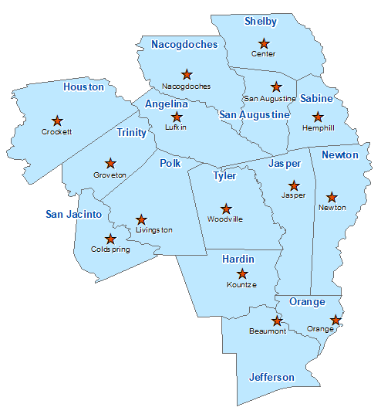Orange County Summary 2021

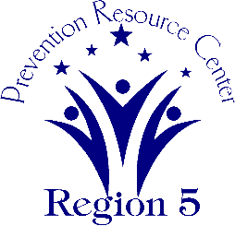The Prevention Resource Center (PRC) provides data for all 15 counties in Region 5. This is a summary of a portion of the data reported in the 2021 Regional Needs Assessment for Orange County. The RNA focuses on underage drinking and tobacco use and on the abuse of prescription medication as well as other illicit drugs.

Population Race/Ethnicity

86,539 White Hispanic Black Asian Other

69,213 6,663 7,773 939 1,951

(80.0%) (7.7%) (9.0%) (1.1%) (2.3%)

Population Growth Language

5.8% English – 93.1% Other Than English – 6.9%

Median Household Income Unemployment Rate

$59,399 10.5

Crime Rate Single-Parent Households

16.8 per 1K 908 (2.9%)

Life Expectancy Suicide Rate

74.3 years 17.6 per 100K

OSAR Screenings

37.2 per 10K